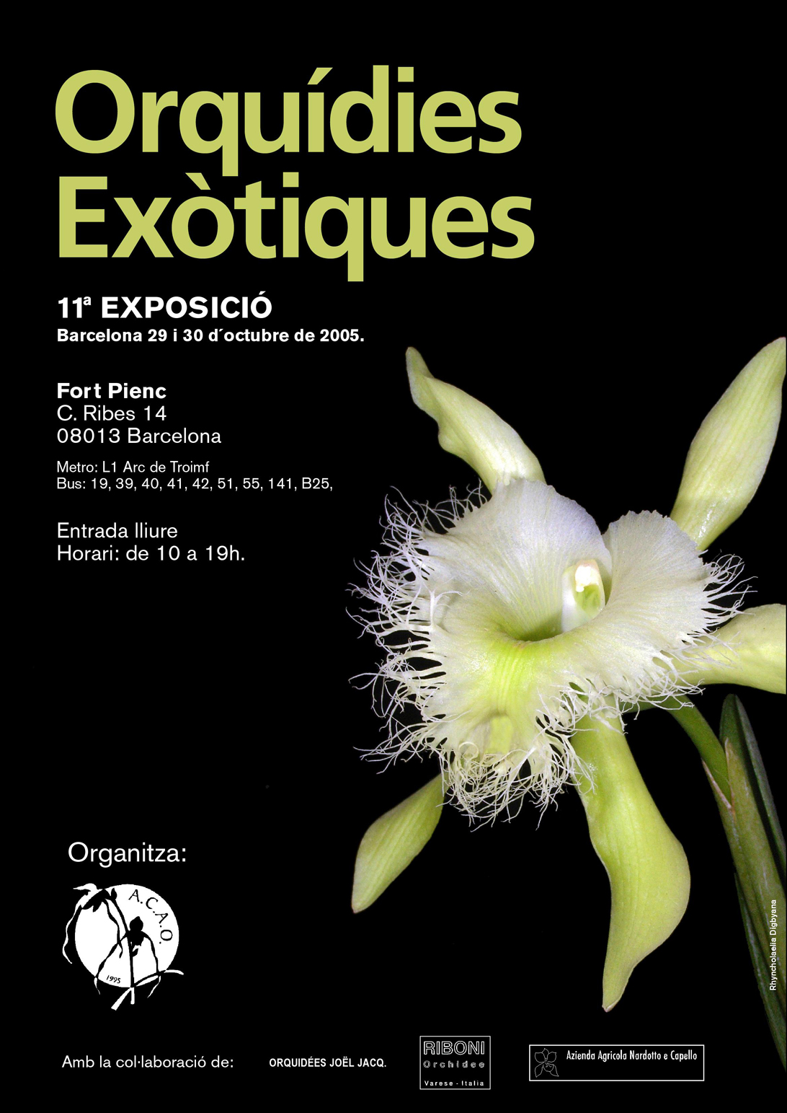
ASSOCIACIÓ CATALANA D’AMICS
DE LES ORQUÍDIES

La Associació Catalana d'Amics de les Orquídies informs you that you are guests to:

11a EXPOSICIÓ D'ORQUÍDIES EXÒTIQUES

The days 29 is 30 of October, will take place in Centre Cívic Ateneu Fort Pienc the 11a EXPOSICIÓN DE ORQUÍDEAS EXÓTICAS.

In this show they were found gathered multitude of varieties of orchids that originate of all the tropical zones of the world. Also they will be presents the Orchids of Catalunya, represented in photographs.

This year Alfredo Riboni with fantastic hybrid and botanical species of insurmountable quality collaborates with us the Italian company/signature. Also the Italian company/signature Nardotto and Capello collaborates in this sample. By I complete, the French nurseryman, Joel Jacq, will have the honor to close the list of this year with his you magnify Orchids. In addition to his stands of collection, will bring a good one I number of their better hybrids and botanical species for their sale.

If you desire it, in the orchid show they will be able to be informed and guided by some of the members of l' Associació Catalana d'Amics de les Orquídies, ( A.C.A.O ), that gladly they accompanied you in a traveled through by the charming world of the orchids.

CONFERENCES & CULTURE FACTORIES

SATURDAY 29:

12 Hs: CULTURE FACTORY & TRANSPLANTS in charge of Pere Arche
18 Hs: CONFERENCE : THE GENUS PAPHIOPEDILUM & THEIR CULTURE in charge of Pere Arche member of A.C.A.O

SUNDAY 30:

12 Hs: CULTURE FACTORY & TRANSPLANTS in charge of Pere Arche
18 Hs: CONFERENCE : MINIATURE ORCHIDS in charge of Pilar Barceló, member of A.C.A.O

FREE ENTRANCE

LOCATION :

CENTRE CÍVIC ATENEU FORT PIENC
  Datos básicos:
  Dirección: |  | C Ribes, 14
  Zona: |  | Estació Nord
  Distrito: |  | Eixample
  Código Postal: |  | 08013
  Teléfono: |  | 932327827
   |  | 932328293 | FAX
  Acceso adaptado
  Utilidades:
  Cerca de aquí
  Mapa
  Cómo ir
  Aparcamiento
  Enviar a un amigo
  Versión para imprimir
  Agenda de actos

MAPE :
http://www.onaparcar.bcn.es/cgi-bin/onaparcar/busca_parc_imi.cgi?idioma=E&descripcion1=C+Ribes,14&coor1_x=31727&coor1_y=83222&proceso=D&tipo_item=0&who=on_aparcar

FOR MORE INFORMATION :

acaoinformació@yahoo.es

